Project Design Phase-II
Technology Stack (Architecture & Stack)

Date | 24 February 2026
Team ID | LTVIP2026TMIDS76018
Project Name | Rising Waters: A Machine Learning Approach to Flood Prediction
Maximum Marks | 4 Marks

Technical Architecture:
The system is a web-based flood prediction application built using machine learning.Users enter environmental parameters such as rainfall, temperature, humidity and cloud cover through a web interface. The backend Flask server processes the input, applies a trained machine learning model, and returns the flood risk prediction. The system uses a StandardScaler for preprocessing and an XGBoost model for prediction. The application is deployed locally and can be extended to cloud deployment.Example: Order processing during pandemics for offline mode.

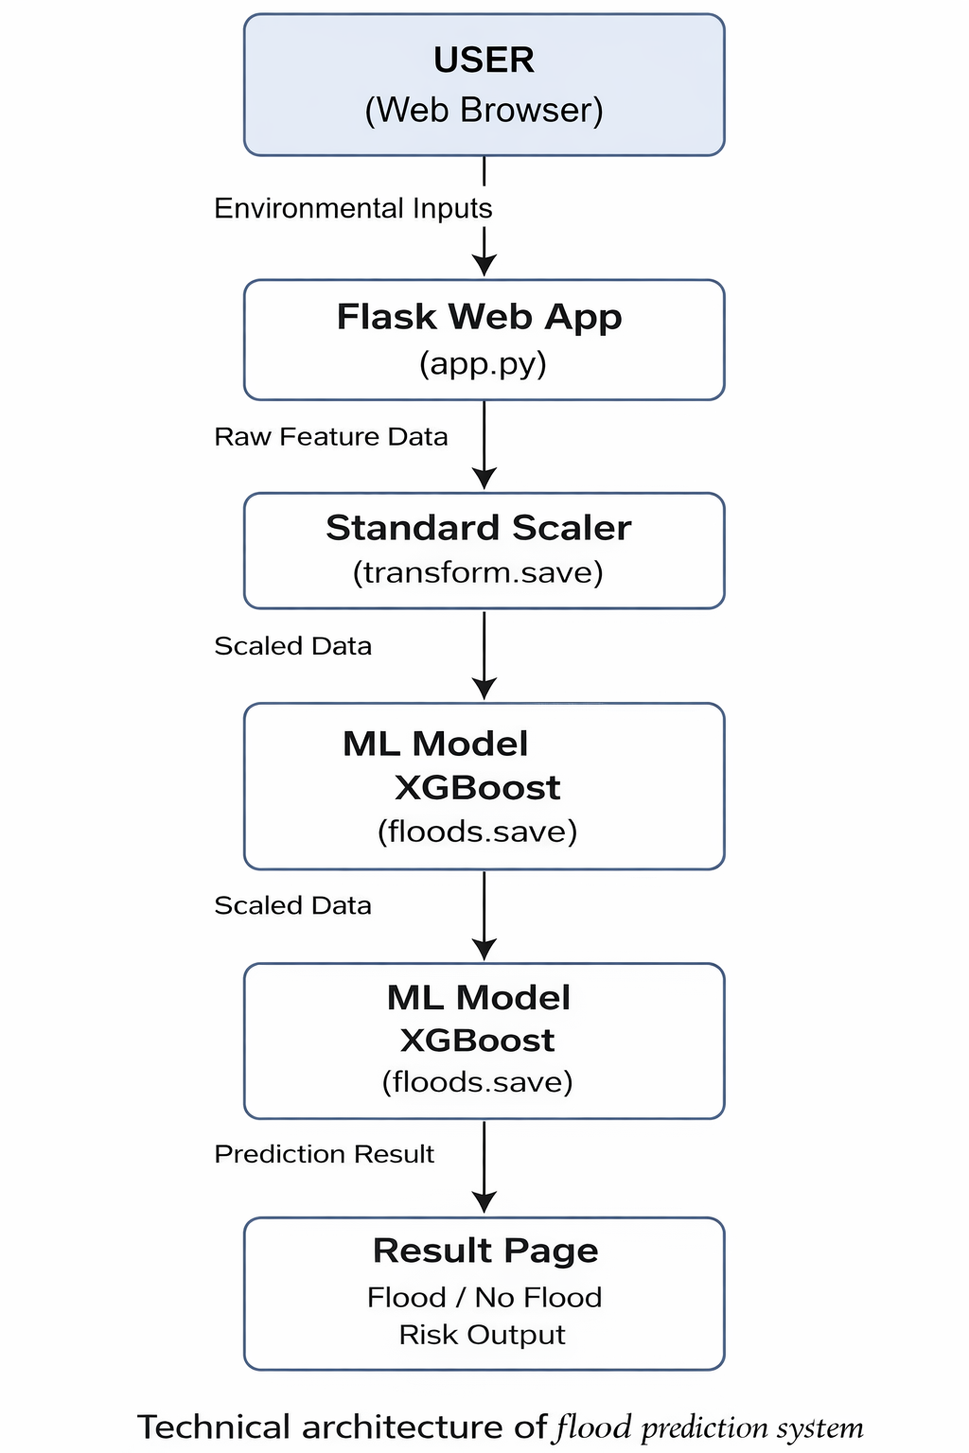

Table-1 : Components & Technologies:
S.No | Component | Description | Technology
 | User Interface | Web interface where users enter environmental parameters and view prediction results | HTML, CSS, Bootstrap, JavaScript
 | Application Logic-1 | Backend logic to handle requests and process user input | Python, Flask
 | Application Logic-2 | Data preprocessing and feature scaling | Scikit-learn StandardScaler
 | Application Logic-3 | Machine learning prediction logic | XGBoost, Scikit-learn
 | Database | Dataset used for model training and testing | Excel Dataset (Pandas DataFrame)
 | File Storage | Stores trained model and scaler | Joblib (.save files)
 | Machine Learning Model | Predicts flood risk based on environmental features. | XGBoost Classifier
 | Infrastructure | Local deployment and testing environment | Anaconda, Jupyter Notebook, Localhost Flask Server

Table-2: Application Characteristics:
S.No | Characteristics | Description | Technology
 | Open-Source Frameworks | Uses open-source libraries for ML and web app. | Flask, Scikit-learn, Pandas, NumPy, XGBoost
 | Security Implementations | Input validation and secure request handling | Flask request handling, basic validation
 | Scalable Architecture | Model can be deployed on cloud and scaled | Flask API, modular architecture
 | Availability | System accessible via web browser locally | Localhost server (can extend to cloud hosting)
 | Performance | Fast prediction using trained model and scaler | Optimized ML model, NumPy processing

